H.T No
Regulations:
A19

Sreenidhi Institute of Science and Technology
(An Autonomous Institution)
Code No: 7M214 Date: 19-Sept-2022 (FN)

M.Tech I-Year II-Semester External Examination, Sept/Oct-2022 (Regular/Supplementary)
ADVANCED FINITE ELEMENT ANALYSIS (TE)

Time: 3 Hours Max.Marks:70

Note: a) No additional answer sheets will be provided.
b) All sub-parts of a question must be answered at one place only, otherwise it will not be valued.
c) Missing data can be assumed suitably.

ANSWER ANY FIVE QUESTIONS. EACH QUESTION CARRIES 14 MARKS.

Bloom's Cognitive Levels of Learning (BCLL)
Remember | L1 | Apply | L3 | Evaluate | L5
Understand | L2 | Analyze | L4 | Create | L6

 |  |  | BCLL | CO(s) | Marks
1. | a) | Distinguish Finite element methods and Finite Volume methods. | L2 | CO1 | [7M]
 | b) | Explain the various steps involved in solving a problem using finite element method. | L3 | CO1 | [7M]
2. | a) | Find the nodal displacements and element stresses in a plane truss shown in the figure  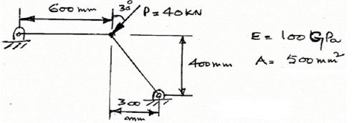 | L4 | CO2 | [7M]
 | b) | Derive stiffness matrix equation for a beam element. | L3 | CO2 | [7M]
3. | a) | The nodal coordinates of the triangular element are shown in figure. At the interior Point P the X coordinate is 3.3 and the shape function at node 1 is N₁ is 0.3. Determine the shape functions at nodes 2 and 3 and also the y coordinate of the point P.  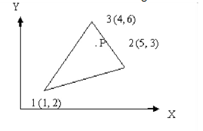 | L3 | CO3 | [7M]
 | b) | Evaluate 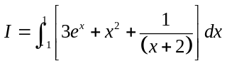  Using one-point and two-point Gauss quadrature method and compare the solution with exact solution. | L3 | CO3 | [7M]
4. | a) | Define Iso-parametric element. | L1 | CO4 | [7M]
 | b) | Define finite element modeling for 2D triangular Element. | L3 | CO4 | [7M]
5. | a) | What is conduction equation for steady state condition? | L1 | CO5 | [7M]
 | b) | A wall of 0.6m thickness having thermal conductivity of 1.2W/m K. The wall is to be insulated with a material of thickness 0.06m having an average thermal conductivity of 0.3 W/m K. The inner surface temperature 1000ºC and outside of the insulation is exposed to atmospheric air at 30⁰C with heat transfer coefficient of 35W/m² K. Calculate the nodal temperatures.  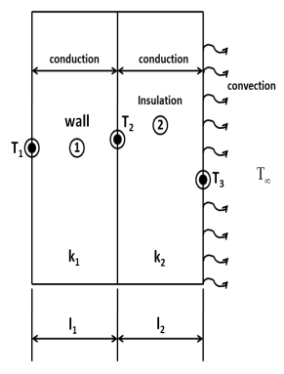 | L3 | CO5 | [7M]
6. | a) | Write down the mass matrix for truss element. | L2 | CO6 | [7M]
 | b) | Derive the elemental mass matrix for two noded beam element. | L3 | CO6 | [7M]
7. | a) | Explain about plane stress and plane strain. | L2 | CO1 | [5M]
 | b) | Write the Hermite shape functions of beam element and plot them. | L3 | CO2 | [5M]
 | c) | How are triangular elements isoparametrically represented? | L2 | CO3 | [4M]
8. | a) | Write the advantages and applications of axisymmetric element. | L2 | CO4 | [5M]
 | b) | Formulate the equation of one dimensional criteria of composite wall. | L3 | CO5 | [5M]
 | c) | Discuss the consistent mass matrix and lumped mass matrix. | L2 | CO6 | [4M]

-- 00 -- 00 –

